MZIMBA NORTH AGRICULTURE PAPER II MARKING KEY
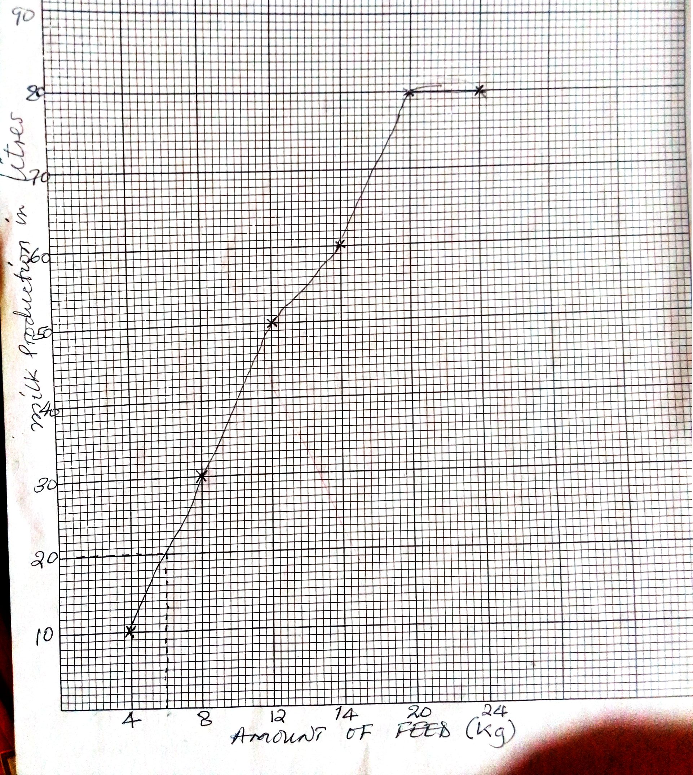

- 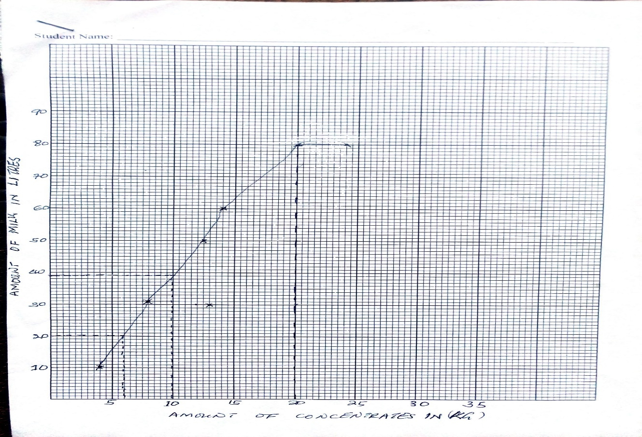
(4 marks)

- 38 liters of milk is produced when 10kg of concentrates is used (1 mark)
- 20 liters of milk is produced using 6kg of concentrates (1 mark)
- 20 kg of concentrates. (1 marks)
- 20 kg of concentrates produces the maximum production of milk which is 80 liters. (2 marks)
- It explains the principle of law of diminishing marginal returns. (1 marks)

- Experiment set up (2 Marks)
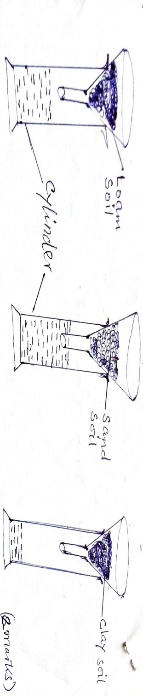
(2 marks for correct drawing)

Procedure (3 Marks)
- Fix filter paper on each funnel and put equal amounts of loam, sand and clay soil.
- Pour equal amounts of water into the funnel containing the soil samples at the same time
- Wait until all the water infiltrates completely into the three soil samples
Observations (2 Marks)
- The three soil samples release the first drops of water into the measuring cylinders at different times
- After some time water levels in the three measuring cylinders are different
Results
- Water takes the longest time to drain through clay followed by loam, and sand soil respectively
- Largest volume of water was collected from sand seconded by loam and clay had the least water volume. (2 marks)
Conclusion
- clay soil has the highest water holding capacity seconded by loam soil and then sand soil with the lowest (1 mark)

- Hay (1 mark)

- goat
- cattle
- sheep (2 marks for any two)

- P has high nutrient content than Q
- P has high digestibility than
- P has high palatability than Q (2 marks for any two)

- Saanen
- Toggenburg
- Anglo - Nubian
- British alpine (2 marks for any two)
- Mastitis (1 mark)

- observing hygiene when milking
- vaccination
- treat with antibiotics
- apply milking jelly after milking to avoid cracking of the teats (2 marks for any two)

- Vegetative plant propagation (1 mark)

- It is bulky hence difficult to carry
- It cannot be stored for long period before planting
- Increased disease susceptibility
- Can easily get damaged in the course of transporting them. (1 mark)

- Can do well even if there are erratic rains
- The crop do not require application of chemical fertilizers which may cause soil pollution
- Can serve as a staple food hence reducing hunger (2 marks for any two)
- Chemical soil degradation (1 mark)
- organic farming (1 mark)

- does not disturb ecosystem since use of organic inputs does not kill beneficial soil organisms such as nitrogen fixers, pollinating insects and earth worms
- cheap because of use of locally available resources
- reduces chances of poisoning since harmful chemical substances are not used
- prevents pollution of water resources with agrochemicals that would be washed away into them
- improves soil structure through use of manure (4 marks for any two)

